GUI

# Introduction.

This application will be used in a factory. It will work on a local server, with aprox. 7 users, connected to it, including Admins. We manufacture pieces based on our client drawings, for ex. 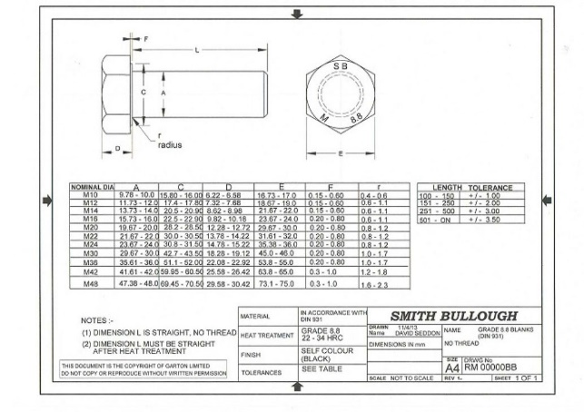

In this example: the drawing nr. Is RM 00000BB

Other thing will be client id for SMITH BULLOUGH (given by us) for ex. 17. So, we don’t say this “order is from smith Bullough” but instead this easy from *“client 17”*

We want our app to be interactive and a lot of feedback from the workers, with an option to notify any problem or need.

Once this short introduction is given I would like to explain why we want this desktop application. We have a main office (here is processed everything from order entry to client contact, pricing, invoicing,) and a production office, on the opposite side of the factory where the production process is planned and executed. Right now, our system is excel based, effective but a little complicated to manage, more over lately there have been lack of communication so we would like to upgrade.

# Structure.

It will have the following structure:

Order entry in the main office Order revision and confirmation/denial in the production office - Send offer to the client from the main office Once Accepted by the client, entry in database in the main office Once in database, create the production process. Before creating the production process the following questions should be answered: When, Who, where (machine), Which (tools), how much (materials), and other processes if there are any (ex. After work)

The notification system will be as easy as: enter drawing code and enter your message. So we can see, user X have notified this about that.

# Interface.

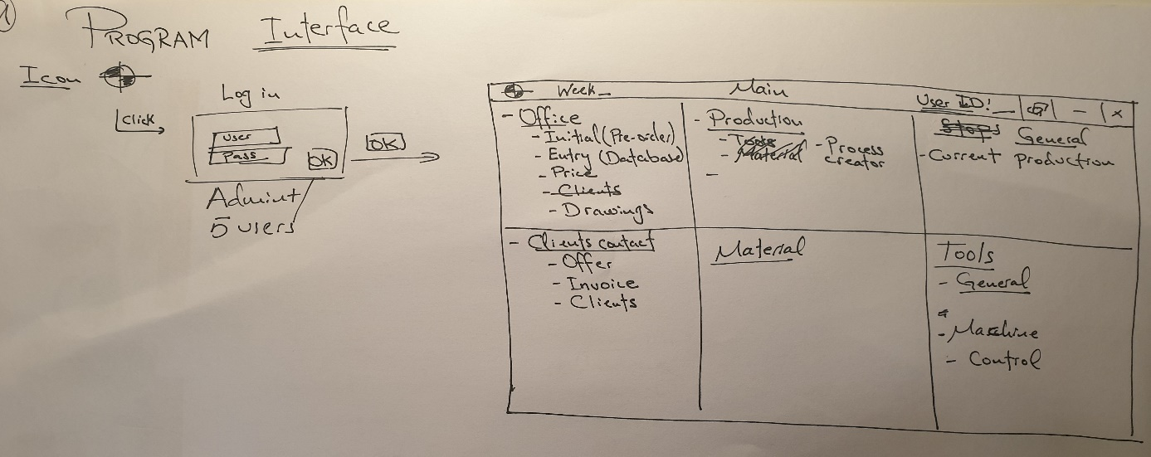

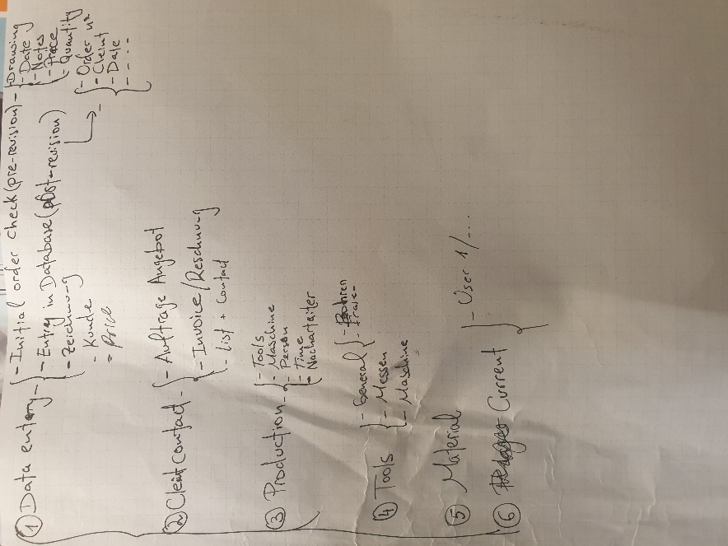

In order to access the application, the user should have an ID and a password

Different user will have access to different windows, administrated by the admin.

The application will be divided in 6 sections:

* Office
* Production
* Material
* General
* Tools
* Inventory

The order will be started from **office**:

Pre-order

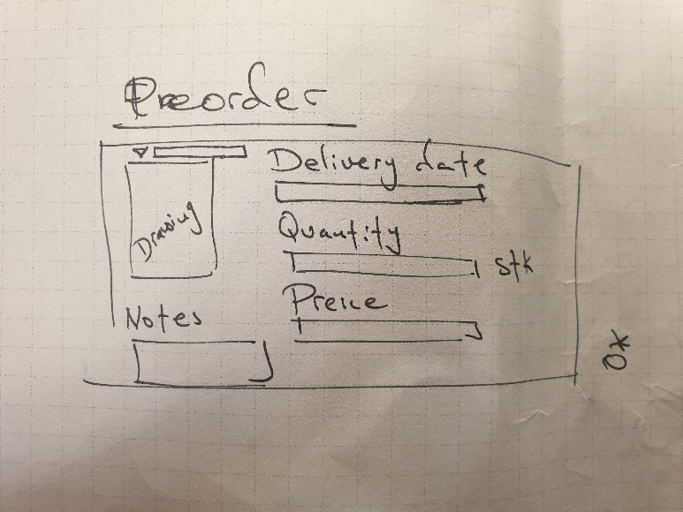

Here we will enter the order that are not confirmed, but for revision.

It will have the drawing **code**; **drawing** openable pdf; **delivery date**; **quantity**; **price** and **other notes.**

From here it will go to a revision list in (General Window):

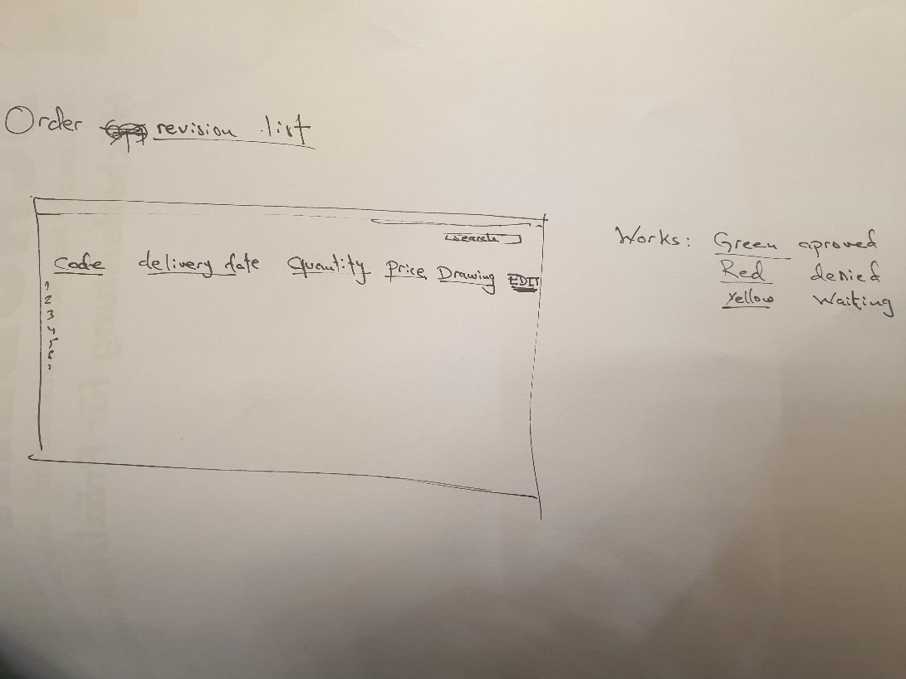

So in production office it will be approved or denied, by editing it.

Green: approved

Red: Denied

Yellow: Not revised yet

To this window both office and production office will have access, so they can see which order is added, which one is approved.. and edit it.

There will be an other tool, for price calculating (Office):

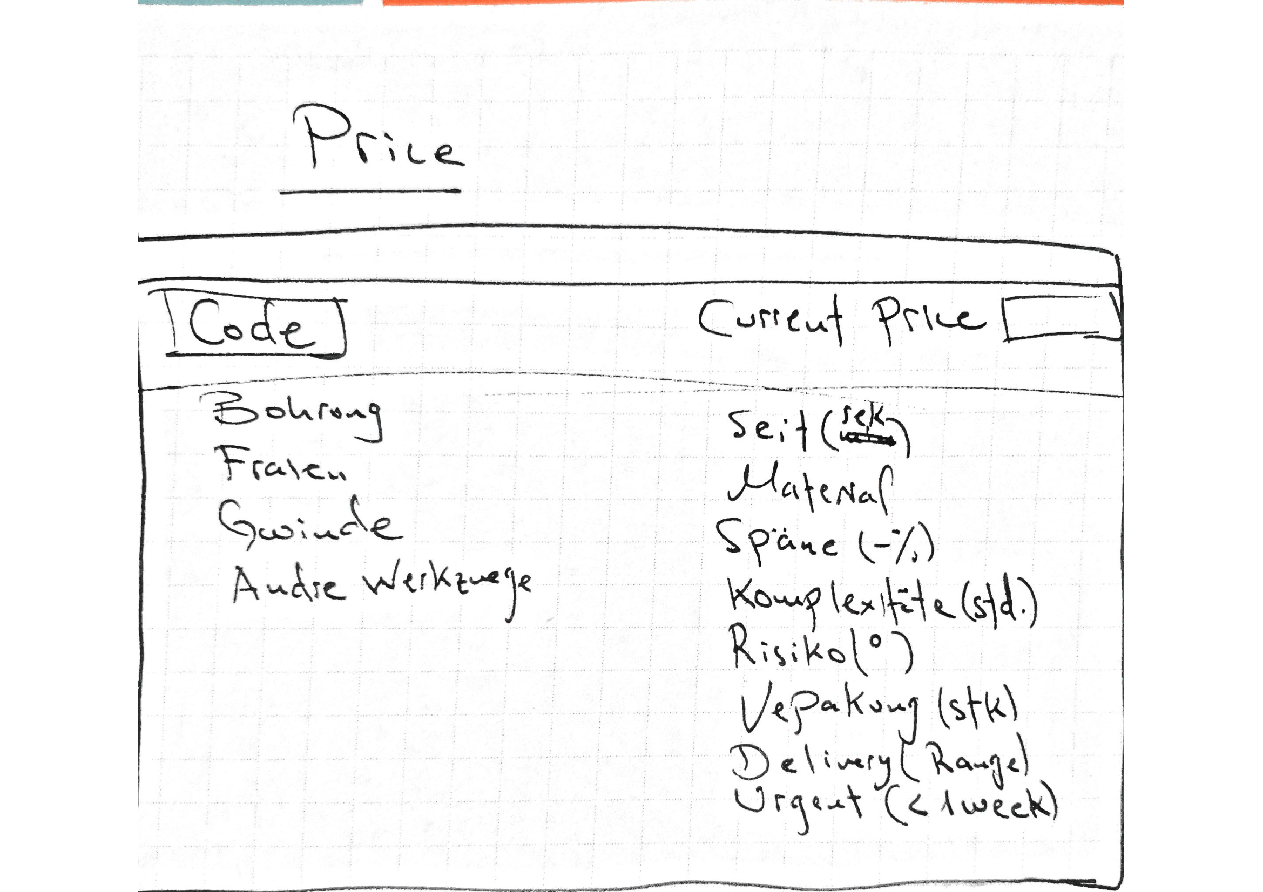

Some of these are defined parameters and other are editables.

So once an drawing is approved from the revision list, an offer will be sent to the customer (office):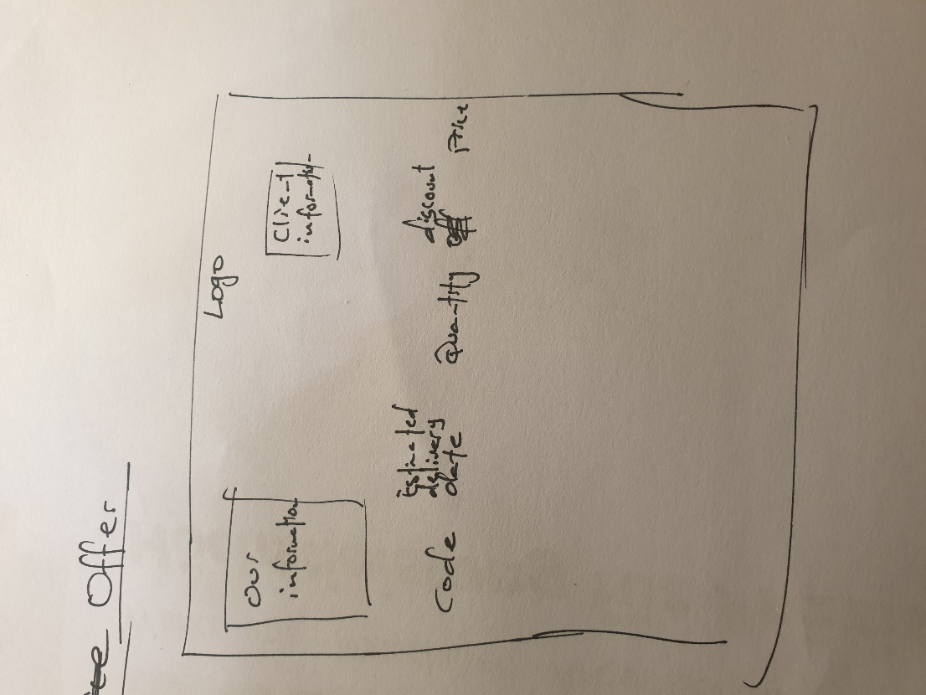

It will contain our company info. Client Info. Company logo.

Product code; Estimated delivery; Quantity; Discount and Price.

Once the customer accepts the offer, the order will be added to the database (office):

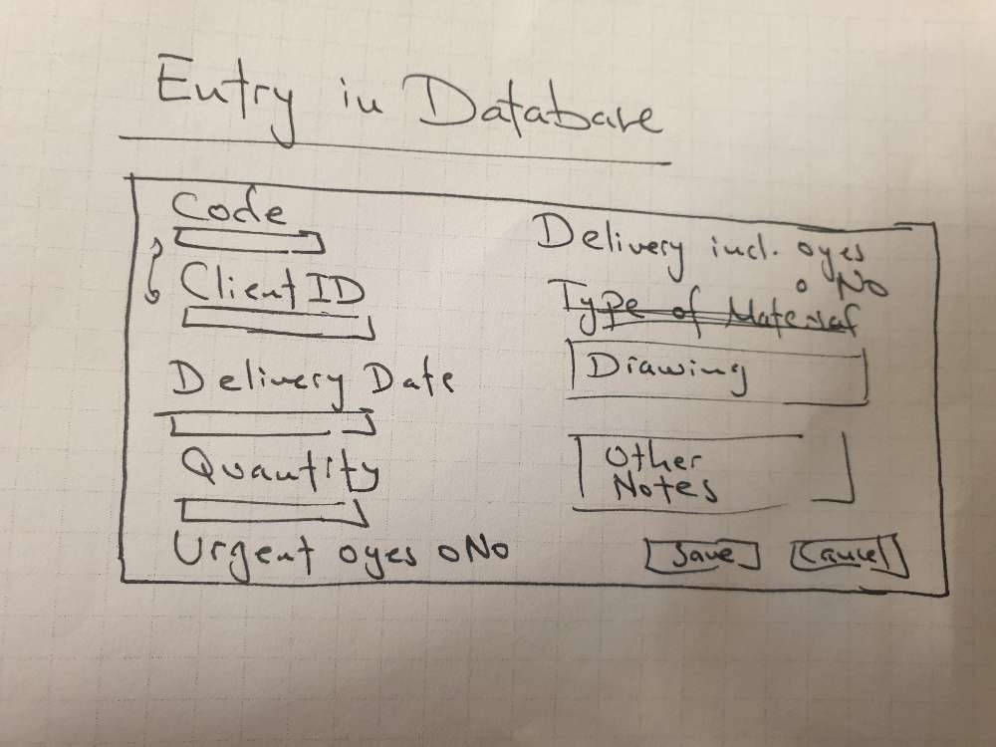

Creating a list of orders.

From this database the production process will be created in the production office (production):

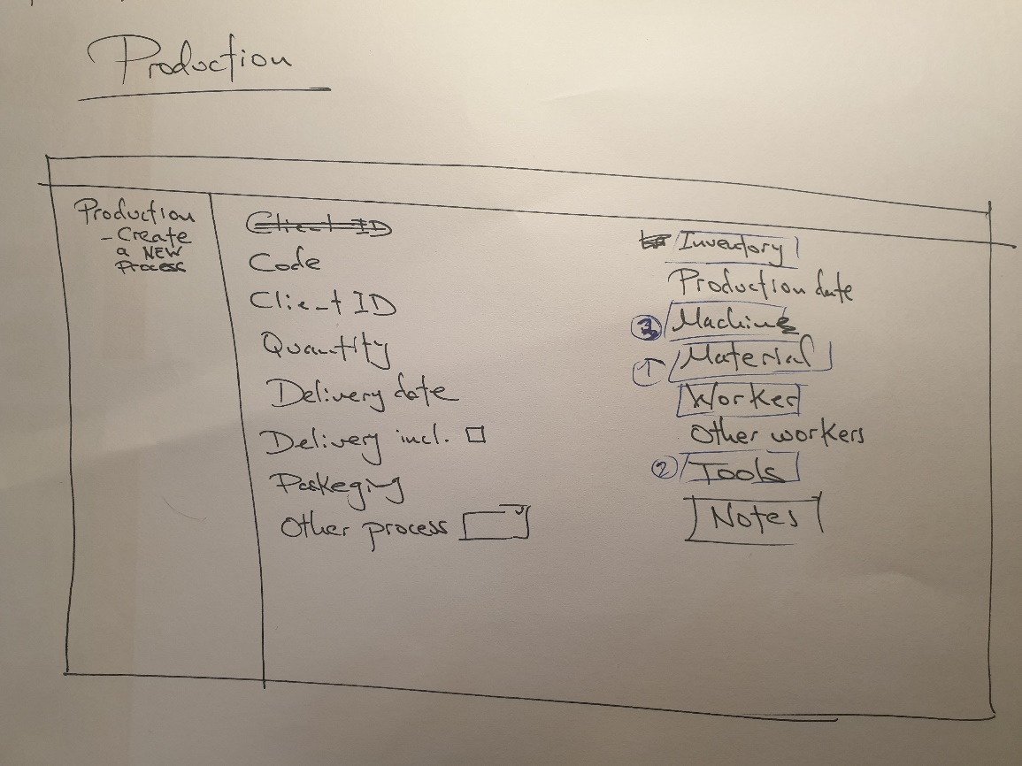

here when we enter the drawing code, if this product have been previously made, all the fillable boxes will be autofilled (client id; in inventory, material, worker, tools, notes,..)

Once the process is created, There will be three different windows will be created: two of them simple: materials and tools, and an other one for workers

Materials (Material)

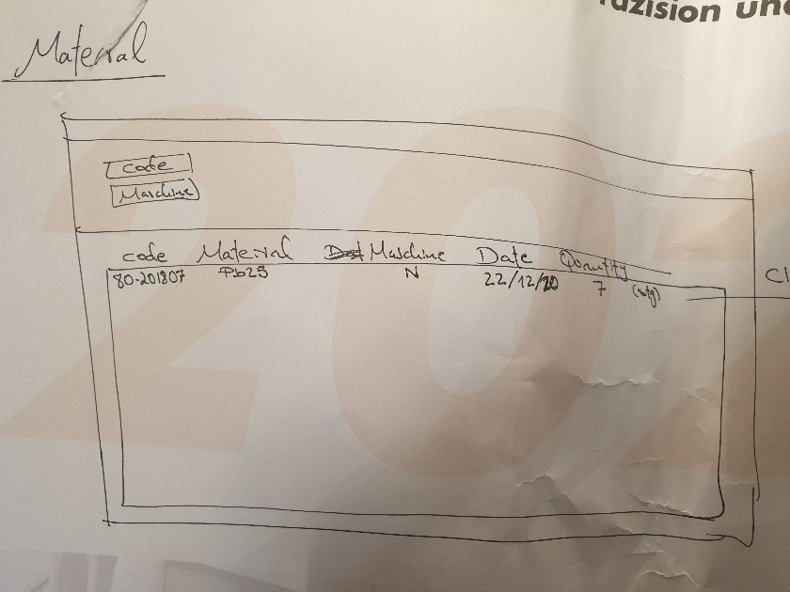

A simple list that tells the person responsible for material, which material is needed for a specific order on which machine, when and the quantity. And if there is not enough/any material, they can notify us with a button or a massage.

Tools (Tools)

Same as material, but in this case, it will tell them which tools are needed.

Workers

Sometimes our workers are who manage directly which will be the order production date, on which machine, and the tools needed. So, what we want is when we create the production process, if we enter the worker id ex. 11, the computer will know that 11 is John´s id, so when John enters the app with his id and password, he can see the order corresponding to him and can edit/manage these three parameters how he wants: production date, machine and tools. And if John want something he can notify us.

# Tools inventory

This app will manage our tools too. So, we can add new tools, see how many pieces of a specific tool we have and edit it.

We have many types of tools but here we will be managing these two types:

1. tools corresponding to machine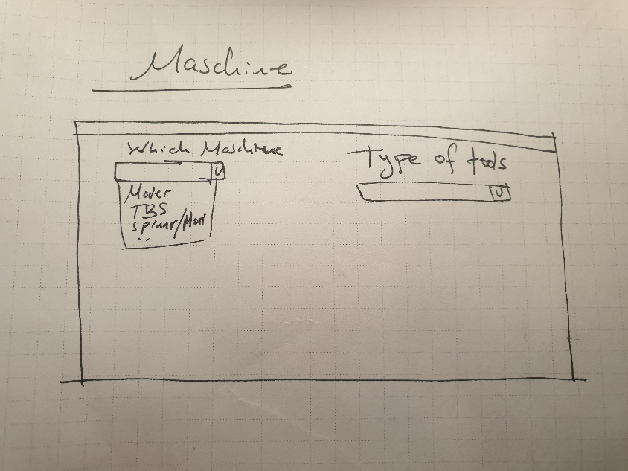

These tools correspond to specific machines. So, we select a machine from A-F and then select the types of tool that is needed.

Example:

Let’s say I need a gear X of machine B:

I’ll go to

1. Tools Inventory
2. Machines
3. B
4. Internal parts
5. Gears
6. Gear X

Just like windows folder works

We want it to be visual. It will be good to have option of adding images to each step. Picture of machine B, of internal parts, gear, etc.

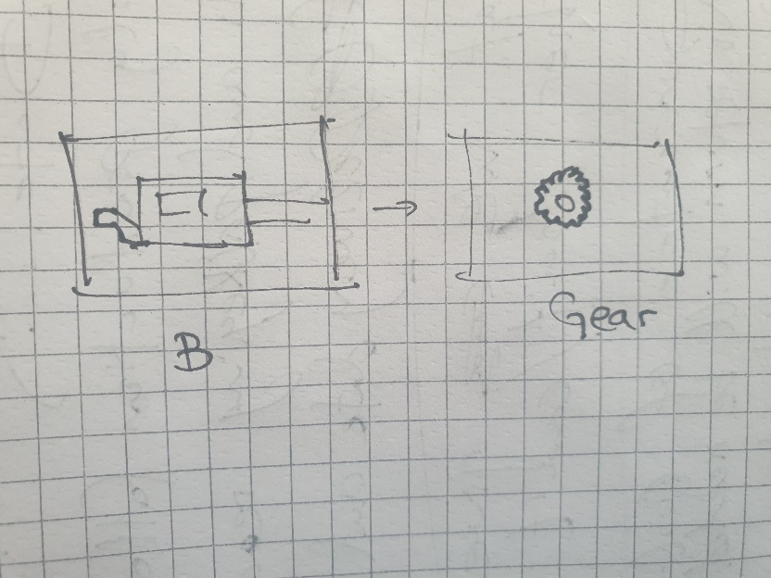

1. Tools for checking general parameters

Same as machine parts, but these would be the tools that can be used anywhere. Very folder-based interface

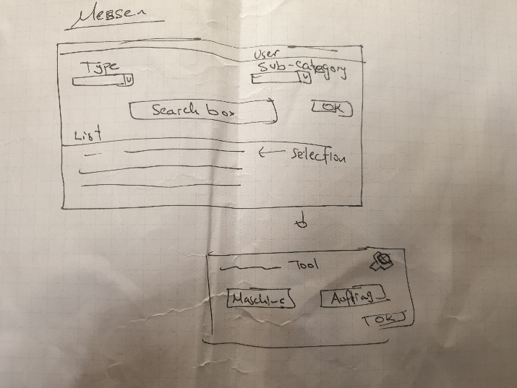

In addition, it can have a search box.

So, it will be as simple as this:

* to tell for which order do you need these tools
* On which machine they are going to be used

Like a shopping cart, the worker can select from different tools and then assign them to a specific order.

They will have to return them too. So, if any tool is broken/lost/isn’t usable anymore/... they will have to notify that this tool is not available anymore.

Once the machine is finished, the worker will notify it, and the packaging department can take the pieces away, count them give it in the application and prepare it for delivery.

Once the office knows how many pieces there are for delivery thy will create an invoice, for that order.

This is the structure of this application. There can be minor changes, but the basis will be the same.